***CURRICULUM VITAE***

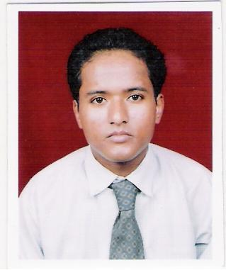

**HARI BHANDARI**

**K-58B, street no- 2, Mahipalpur, New Delhi- 110037**

**[hari_bhandari27@yahoo.com](mailto:hari_bhandari27@yahoo.com) Mobile:-+91-9871761930**

I

**CAREER OBJECTIVE**

**To serve an organization where Growth of both the organization as well as my career in the organization**

PROFILE

Over 9 years experience with different fields Finance sector, Retail (supermarket, showroom), securiy

Department and Tour and Travels looking for executive role or office assistant with excellent customer service skills

**WORK EXPERIENCE**

1. Currently working with Magma fincorp Ltd. As a executive in recovery department since Feb 2016 to till date in Delhi
2. **4 years worked as a salesman for AL-WAFA supermarket Saudi Arabia 2004 to 2008**

**3. 2 years and 6 months as a security officer / office assistant with AC/ First Af ghanistan with U.S soldiers Jan 2012 to Jun 2014**

**4. 2 years worked as a maintenance supervisor in hotel International Inn in facility department delhi 2008 to 2011**

**EDUCATIONAL QUALIFICATION**

**Graduation (B.A pass) from Rajasthan University in 2017**

**Senior secondary 12 th from CBSE board Delhi in 1999**

**Secondary 10 th from CBSE board Delhi in 1997**

**COMPUTER EDUCATION**

**Advance diploma course in computer in 2001**

**Ms word , Excel , and Internet**

**PERSONAL DETAILS**

* **Father’s Name :Late Mr. Dhan Bahadur**
* **Date of Birth: 12th June 1981**
* **Nationality : Indian**
* **Marital Status : Married**
* **Religion : Hindu**
* **Languages known : English, Hindi, Arabic**
* **Height : 156 cm**
* **Hobbies : Listening music and Playing cricket**
* **Weight : 60 kg**
* **Passport number : G9546363**
* **Date of issue : 25-08-2008**
* **Date of expiration : 24-08-2018**
* **Place of issue : Delhi , India**

**DECLARATION**

**I declare that all the details furnished above are true and correct to the best of my knowledge**

**Place: New Delhi**

**Date:**

**Hari Bhandari**